**CMS For E-commerce (Suggestion)**

Requirements: Laravel and Tailwind

**Intuitive Navigation**

- Heirarchy of Navbar should depend on the users needs from most priority to less priority I.e: ***Dashboard -> Products -> Blogs*** **or** if its an e-commerce but solely depends their sales on affiliate we can do the Heirarchy like this ***Dashboard -> Blogs -> Products***

- Include Subpages i.e: Instead of separating **Blogs** and **Banners** in a navbar turn them into Subpages instead create a main navbar named **Content Management**

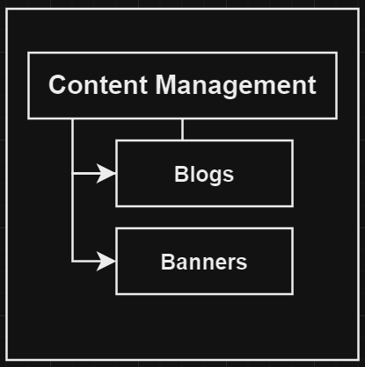

**Content Management**

- For Blogs/Articles

- Custom Landing Pages (Banners) to create Carousel

**CRM (Customer Relationship Management)**

* Purchase History of Customer

**Product Management**

* Inventory Control and Product Variaton/Categories

This is **Optional** if the client wants to keep track of their stocks in their physical warehouse this also comes with stocks depending on the item variant i.e **Red T-shirt Stock: 40, Black T-shirt Stock: 4**

* Product Categories

Items/Products should have categories that can also be filtered out

**SEO Optimization**

* Practice SEO especially customer friendly URL’s ***(e.g., www.example.com/products/red-t-shirt instead of*** [***www.example.com/products?id=123***](http://www.example.com/products?id=123)***).***
* Using relevant keyword in URL to improve search engine rankings.
* ALT tags on Images and Image Descriptions i.e: <img src="path/to/red-cotton-tshirt.jpg" alt="Red cotton t-shirt with round neck and short sleeves">